Slow Motion Calm Down Sensory Bottle
We are long time lovers of sensory bottles but this one wins the prize for all-time, most mesmerizing! It is a fabulous tool to use with children experiencing big emotions. They can breathe as they watch the Lego bricks fall and focus, slow down or calm down, depending upon the moment.
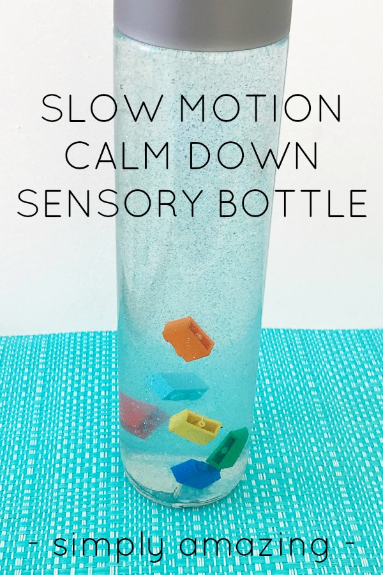
My girls haven’t stopped turning it over and watching it – the photos just don’t do it justice at all! In fact, every single time one of them walks past it, they flip it and stop and watch the bricks fall. They slow down and breathe, and I think it’s simply marvellous.
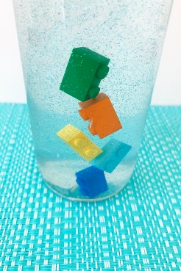
With just two simple ingredients that create the flow, this is easy to make but please be sure to read the directions carefully and to test your bottle well before sealing. You can also see the video below for an overview of the process.

Slow Motion Calm Down Sensory Bottle
You will need:
- Clear hair gel
- Warm water
- A tall bottle
- Lego 2 stud bricks
- Fine glitter
- Super glue or tape to secure lid (optional)
To make:
1. Combine 1 part hair gel to 6 parts warm water. Let cool completely and settle.
2. Pour gel/water mix into the bottle.
3. Add a little fine glitter and your Lego bricks. Push the bricks below the surface to remove any air bubbles.
4. Fill the bottle right to the very top with the remaining mixture.
5. Put on lid, shake vigourously and test your bottle. If the bricks fall too slowly, empty the mixture back into a bowl and add a little more warm water. Let cool again and re-test. If the bricks fall too quickly, mix in a little more hair gel. Let settle and re-test.
6. Once you are happy with the flow of your sensory bottle, secure the lid – a waterproof glue or wide, clear packaging tape will help to keep it secure from curious little fingers.
Flip your bottle over for some slow, relaxing breathing as you watch the bricks fall…as you can see, it’s quite mesmerising!

