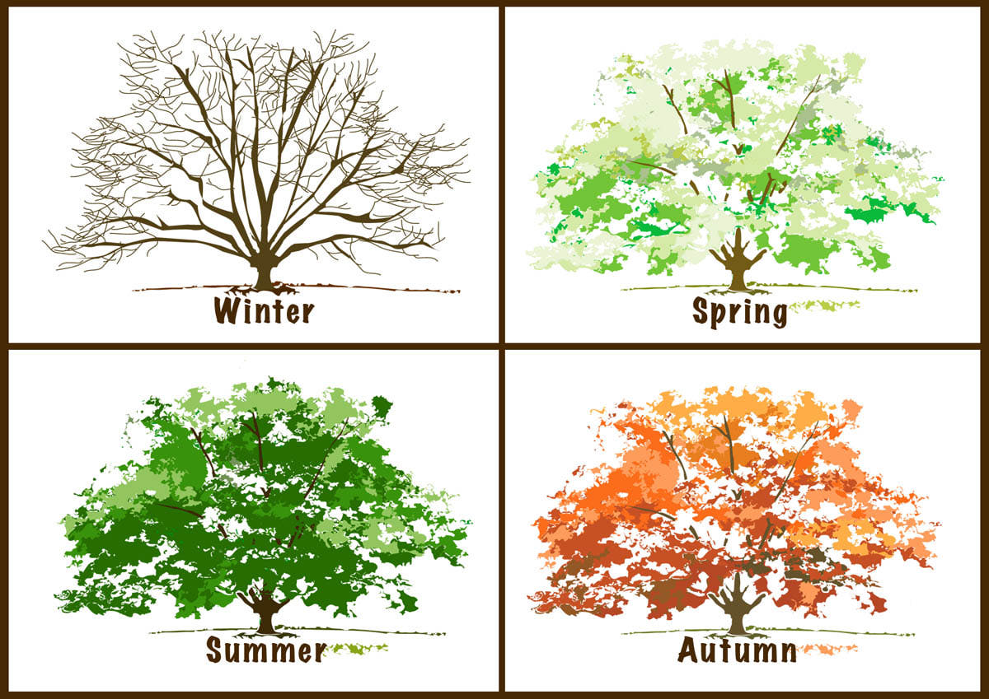

This is a simple way to facilitate a discussion about changes around us that we cannot control. Show the picture and ask participants to describe what they see. Then encourage them to expand on this, and ask question to elicit that these are changes that happen every year, and that we cannot control them.
You may choose alternative images and/or concepts, such as weather rather than seasons. And these represent things that we have no control over at all.
Or the rolling of dice, which illustrates something that we can initiate but cannot control the outcome.

